User's
Manual

Virtual Labs 3.0
guacamole-performance-test.py

Juan C. Riano

Florida International University, Summer 2015

Copyright © by Florida International University – Senior Project – Virtual Labs
All rights reserved. No part of the Virtual Labs Project may be reproduced or transmitted in any form or by any means without prior written consent.
Table of Contents
1 General Information 4
1.1 System Overview 4
1.2 System Requirements 4
2 Environment Setup 5
2.1 Test Setup 5
3 Running the Script 7
3.1 Script Results 9
4 Test Script Shortcomings 11

1 General Information

The guacamole-performance-test.py is a script written with the purpose of measuring the performance hit taken by a Linux server running the Guacamole Gateway as remote RDP connections are established.

1.1 System Overview

Guacamole (http://guac-dev.org/) is an HTTP5 Gateway that allows users to connect to remote computers by using open source libraries for the SSH, RDP and VNC protocols.

For this test Guacamole will be installed in a Ubuntu server 14.04.

1.2 System Requirements

All the tools used for this test are open source of free Linux tools:

- Ubuntu 14.04 web server
- Sysstat for CPU usage measuring (specifically the mpstat command).
- Free (the free command is used for memory usage measuring).
- Guacamole 0.9.6
- Guacamole NoAuth extension (not mandatory but recommended)
- Python 2.7
- Pygal (http://pygal.org/) for charting
- RDP computers set up to connect to. (Configuring Guacamole documentation)

2 Environment Setup

This document describes a particular setup, using the tools named in the previous section. Other setups may be possible by making sure the required tolls are in place.

Since the script is intended to run while RDP connections are established, it is highly recommended that a testing Guacamole environment is used, and that this test environment is running the NoAuth extension (http://guac-dev.org/doc/gug/noauth.html#installing-noauth). Using this extension will allow the tester to quickly open connections without having to provide username/passwords for each connection. This test uses such extension.

2.1 Test Setup

To run the test quickly, the Guacamole server should be running the NoAuth extension, which allows you to see all the available connections in the main page as shown bellow.

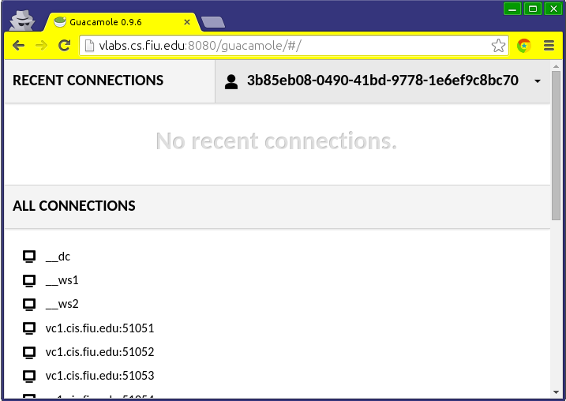
If the test intends to create many connections, it is better to create an HTML file with all the target computers listed as links, where each link is setup with a target computer's hostname information.

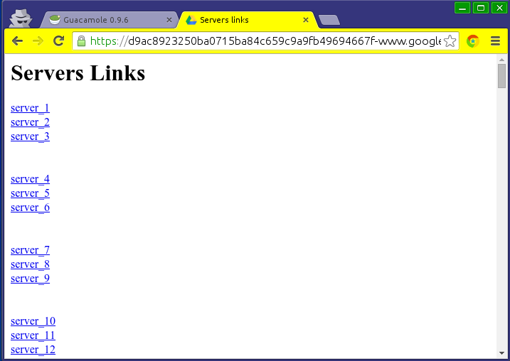

<html>
<head><title>Servers links</title></head>
<body><h1>Servers Links</h1>
<a target="_blank" href="http://vlabs.cs.fiu.edu:8080/guacamole/#/client/c/vc56.cis.fiu.edu:77777">server_1</a>
</br>
<a target ...
</html>

The guacamole-performance-test.py script outputs 5 files in the same folder where it resides, thus, it is recommended to run it from inside an empty folder created just to run the test. This folder can be in any location.

The script needs to be run with sudo, as it needs to read the system logs, which are restricted.

3 Running the Script

The first step is to make sure that the script is executable.

$ chmod +x guacamole-performance-test.py

Then run the script providing the location of the server's system log.

$ sudo ./guacamole-performance-test.py /sys/log/syslog

This will start the script and provide the initial memory and CPU values.

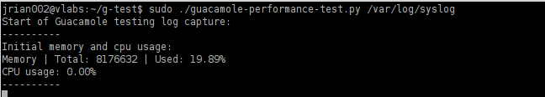

Then as new connections are opened by the Guacamole gateway, the script shows the connections and the changes in memory and CPU usage generated by Guacamole.
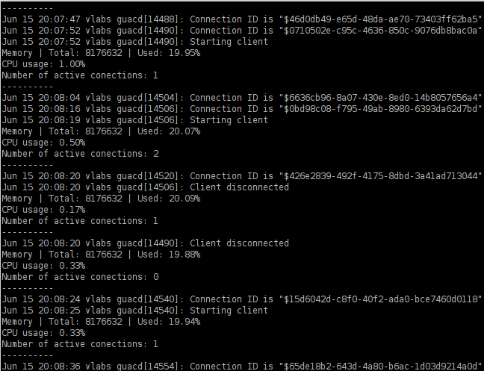

Finally, when the script is stopped with Ctrl-C, the latest values are shown in the terminal, and new files can be found in the folder.

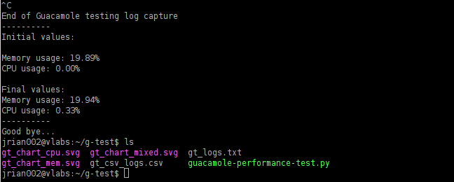

3.1 Script Results

The files generated by the script are 2 log files (the ones in .txt and .csv formats), and 3 charts (.svg files) that are better viewed in Google Chrome, as they may show blank in some viewers.

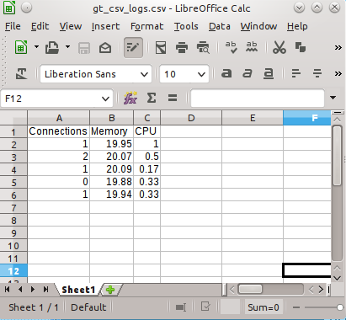

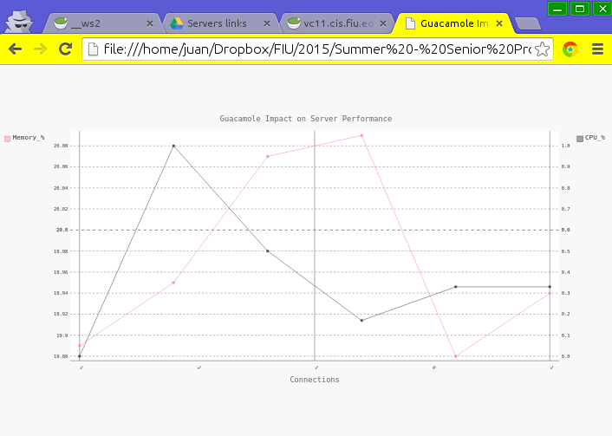

4 Test Script Shortcomings

This script uses pygal 1.7 to create the charts. This library has a css but that causes the final .svg files produced to render as blank pages in some viewers. Please open the charts with Google Chrome if you can't see see it properly in your favorite viewer.

